** EAST WEST UNIVERSITY**

**Experiment No:** 01

**Course Code:** ICE470

**Course Title:** Numerical Method Lab

**Experiment Name:** Determine the Taylor series and compare their result with true value using MATLAB.

**Submitted To:**

Mr. Rasel Ahmmed  
 Lecturer, Department of ECE

**Submitted by:**

Md. Tariqul Islam  
**ID NO:** 2014-2-50-021

**Date of Performance**: 10.05.2018

**Date of Submission:** 24.05.2018

**Experiment No: 01**

**Experiment Name:** Determine the Taylor series and compare their result with true value using MATLAB.

**Objective:** **1.** To know the basic of Taylor series for future academia.

**2.** To assure the comparison of true and relative error using MATLAB.

**1. Program Code :**

clc;

clear all;

a = -0.1;

b = -0.15;

c = -0.5;

d = -0.25;

e = 1.2;

h = 1;

x = [0 1];

y = a*x.^4+b*x.^3+c*x.^2+d*x+e;

figure(1)

plot (x,y,'o')

xlim([-1,2])

ylim([-.2,1.5])

f_1 = 4*a*(x(1))^3+3*b*(x(1))^2+2*c*x(1)+d;

y_1_order = e+(f_1)*h;

f_2 = 12*a*(x(1))^2+6*b*x(1)+2*c;

y_2_order = e+(f_1)*h+(h^2)*(f_2)/factorial(2);

f_3 = 24*a*x(1)+6*b;

y_3_order = e+(f_1)*h+(h^2)*(f_2)/factorial(2)+(h^3)*(f_3)/factorial(3);

f_4 = 24*a;

y_4_order = e+(f_1)*h+(h^2)*(f_2)/factorial(2)+(h^3)*(f_3)/factorial(3)+(h^4)*(f_4)/factorial(4);

disp(y_1_order)

disp(y_2_order)

disp(y_3_order)

disp(y_4_order)

figure(2)

plot([y_1_order y_2_order y_3_order y_4_order])

**Figure 1 :**

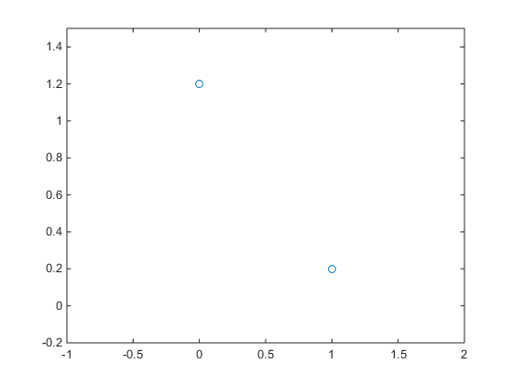

**Figure 2 :**

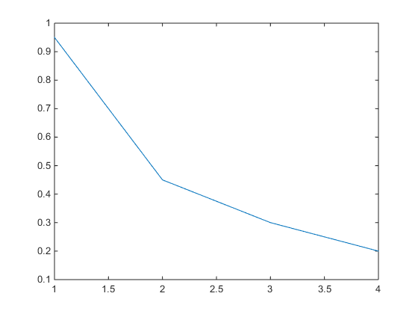

**2. Program Code :**

clc;

clear all;

a = -0.1;

b = -0.15;

c = -0.5;

d = -0.25;

h = 1;

x = [0 1];

y = a*x.^3+b*x.^2+c*x+d;

figure(1)

plot (x,y,'o')

f_1 = 3*a*(x(1))^2+2*b*x(1)+2*c;

y_1_order = (f_1)*h;

f_2 = 6*a*x(1)+2*b;

y_2_order = (f_1)*h+(h^2)*(f_2)/factorial(2);

f_3 = 6*a;

y_3_order = (f_1)*h+(h^2)*(f_2)/factorial(2)+(h^3)*(f_3)/factorial(3);

disp(y_1_order)

disp(y_2_order)

disp(y_3_order)

figure(2)

plot([y_1_order y_2_order y_3_order ])

**Figure 1 :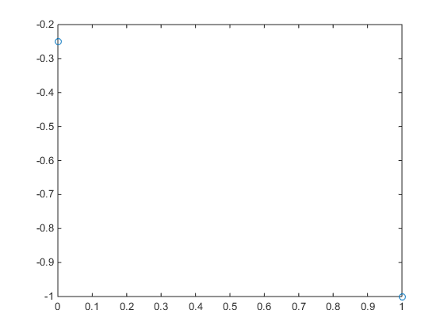 Figure 2 :  
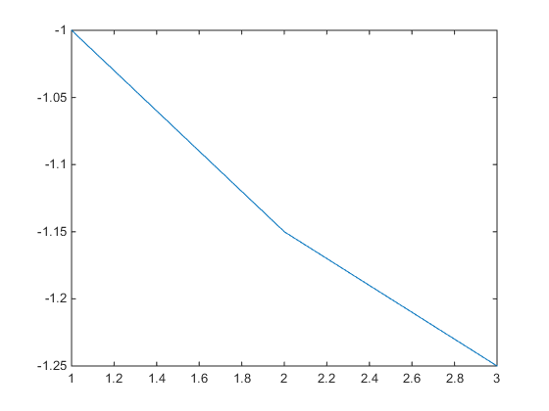**

**Discussion:** This experiment name is Determine the Taylor series and compare their result with true value using MATLAB. There are two program codes. The values and a equation is given in the code by which i have to perform the code. Plot command use to plot the graph of the given function. xlim([xmin xmax]) & ylim([ymin ymax]) sets the axis limits in the current axes to the specified values. disp([X](https://www.mathworks.com/help/matlab/ref/disp.html#btnow0n-1-X)) displays the value of variable X. f_1, f_2, f_3, f_4 is done by **differentiating**. f_1 equation got by **differentiating** y, f_2 equation got by **differentiating** f_1, f_3 equation got by **differentiating** f_2, f_4 equation got by **differentiating** f_3. Then there remains only a value. After **differentiating** each equation I got y_1 order, y_2 order, y_3 order by using Taylor series rule  


It can be also written as  
  
After all the code has been done then I got two figures. The program code 2 is same as program code 1. The equation is different. The necessary values are given in the frogram code. Another thing is different here is that there is no value of e, which was in program code 1. So, Taylor series rule

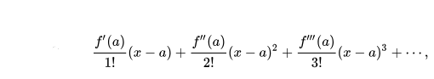

This program code too shows two figures. Figure 1 plots x, y and figure 2 plots y_1_order, y_2_order, y_3_order. This is easy to perform in matlab.